Java Step Types for TestStand

Introduction
Use Java step types to access Java code. Java step types call compiled Java class files (.class) using the Java Native Interface (JNI) and permit the invocation of methods located within these classes. The Java step types currently support Java 2 version 1.4. You can download the Java 2 version 1.4 run-time system from the Sun Web site at http://java.sun.com/j2se/1.4/download.html.

System Requirements
Minimum system requirements include the following:
- TestStand 3.0 or later
- LabWindows/CVI 6.0 Run-Time Engine
- Java 2 version 1.4

SequenceFileLoad Callback
The example sequence file, computer.seq, contains a SequenceFileLoad callback. This sequence is automatically executed when you open the sequence file. The SequenceFileLoad callback copies the JavaCall.dll and JavaCall.uir from the <TestStand Public>\Examples\Java directory, located at C:\Documents and Settings\All Users\Documents\
National Instruments\TestStand x.x\Examples\Java on Windows 2000/XP and at C:\Users\Public\Documents\National Instruments\
TestStand x.x\Examples\Java on Windows Vista, to the
<TestStand Public>\Components\StepTypes\Java directory. The Java step types call functions within this DLL, which must be located in a TestStand search directory for the step types to locate the DLL.

Building the Java Step Types Project
You must install the Java SDK before you can build the accompanying project. Download the Java 1.4 SDK from the Sun Web site http://java.sun.com/j2se/1.4/download.html.

To build the project, install the following files from the Java SDK:
- jni.h—Located in the include folder
- jni_md.h—Located in the include\win32 folder
You must update the path of the Instrument Files in the project to reflect your installation of TestStand and LabWindows/CVI. You can find the Combo Box Instrument File in the <CVI>\toolslib\custctrl directory.

Java Step Types
The Java step types support the creation and cleanup of the Java virtual machine (JVM), as well as the manipulation of objects existing within the JVM through method calls. The Java step types support the use of all Java primitive types and strings, which you can use to pass data between TestStand and Java objects. The step types rely on JavaCall.dll, a LabWindows/CVI 6.0 library, for TestStand to interface with Java. The LabWindows/CVI 6.0 library communicates with TestStand using an ActiveX interface and communicates with Java through the JNI.
Java uses the JNI Sun technology to call compiled code written in C/C++ and to access Java code from C/C++. Refer to the following websites for more information about JNI technology:
- http://java.sun.com/j2se/1.4/docs/guide/jni/index.html
- http://java.sun.com/docs/books/tutorial/native1.1/index.html
The Java step types consist of the following step groups:
- StartStop—Contains steps that start and destroy the JVM.
- Methods—Calls a particular Java method in a specified class.
- Static Methods—Calls a particular static class method in a specified class.
The CallStaticJavaMethod and CallJavaMethod steps are comprised of four steps: Numeric Limit Test, String Value Test, Pass/Fail Test, and Action.
Use one of the Java step types to call JavaCall.dll, which extracts information about the step type from TestStand using ActiveX calls and then calls the appropriate method in the JVM using the JNI interface. For example, use the CallJavaMethod step to call the InvokeJavaMethod function in JavaCall.dll, which calls the TestStand Engine to extract the class, method, and parameter information and instantiate the class within the existing JVM. The method is identified and called with parameter values taken from TestStand. JavaCall.dll then passes back the return value to TestStand.

Using the Java Step Types
Use The StartJVM and DestroyJVM steps in pairs with the steps to call methods located between each pair of StartJVM and DestroyJVM steps. A typical sequence is structured with the StartJVM step, which you place in the Setup step group, followed by a number of Methods or Static Methods steps, which you place in the Main step group. Place the DestroyJVM step in the Cleanup step group.
The Static Methods step type is designed to call static (class) methods, whereas the Methods step type is intended for calling other methods of the class. The Methods step automatically loads the appropriate class and creates a new instance of the class before making the call to the method. The Static Methods step does not create a new instance of the class before making the call. This action of creating objects of the class differentiates the Methods steps from the Static Methods steps.
Methods and Static Methods steps include the following:
- Numeric Limit Test—Used to call methods that return a numeric value (byte, int, short, long, float or double). You can compare the value returned to a set of limits to determine if the step passed.
- String Value Test—Used with a method that returns a String value (string or character). The returned value is compared against a String value.
- Pass/Fail—Used with Boolean return values.
- Action—Used with any type of return value.
Configure the StartJVM step to provide the class path, which is the path of the Java classes to be accessed. Right-click the step and select Edit Java Class Path Location from the context menu to configure the class path, as shown in Figure 1-1.

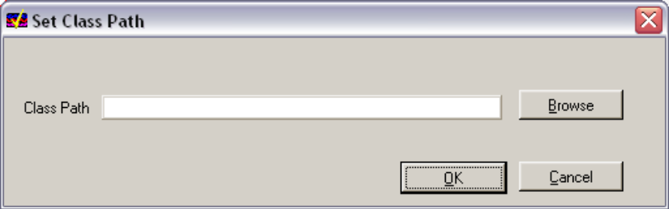

Figure 1-1. Set Class Path Dialog Box
Include all Java classes that are accessed in the class path. If you leave the class path empty, the JVM is unable to locate the user-written Java classes. To set the directories in the class path, click Browse to launch a File dialog box where you can view various directories. After you add the directories that contain the Java classes to be called, click OK to return to the Set Class dialog box, which shows the updated class path. Click OK to save this class path in the step type.
Right-click the step and select Edit Call or Edit Static Call from the context menu to launch the Edit Java Call dialog box and configure the Methods and Static Methods steps to call the appropriate Java method, as shown in
Figure 1-2.
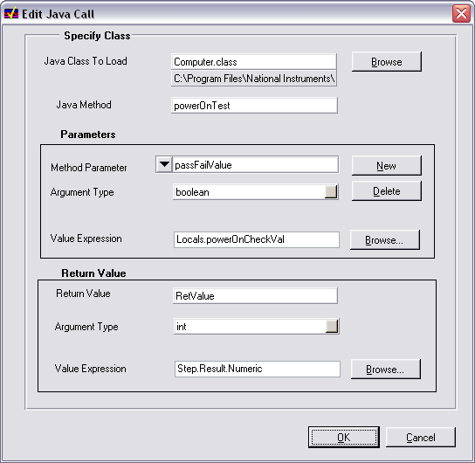

Figure 1-2. Edit Java Call Dialog Box
Follow these steps to configure a Methods step:
- Select the Java class containing the method by clicking the Browse button located next to the Java Class To Load control.

 | Note | Always use a relative path for the Java class to load. If you use an absolute path, JVM cannot locate the class name and you receive a Class Not Found error (-1000).

If TestStand cannot locate the file, it launches the File Class Not Found dialog box, which is shown in Figure 1-3.
- Select Add the directory containing the file you selected to the list of search directories in this dialog box.
Do not select Use an absolute path for the file you selected.
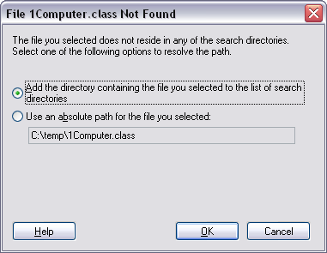

Figure 1-3. File Class Not Found Dialog Box
If the file displayed in the path below the class name is incorrect, add the appropriate folder to the TestStand search paths or move the folder containing the file to a higher position in the list of search directories. Select Configure»
Search Directories to configure the search paths in the sequence editor.
- After you select the file containing the class to call, enter the name of the method to call.
- Follow these steps to create a new parameter item for each parameter to pass to the new method:
  - Click the New button in the Parameters section of the Edit Java Call dialog box.
  - For each item, specify a unique name for the parameter, the parameter type, and the value to pass.

 | Note | These types are the Java types represented in the Java method header. If the value to be passed is stored in a TestStand variable, click Browse to locate the TestStand variable. Otherwise, enter the value of the parameter.  Verify that the type of the value or TestStand variable is compatible with that Java parameter type. Refer to Table 1-1 for a list of compatible types.

 | Note | Enclose both literal strings and literal characters in double quotes (“”).
- To create more parameter items, click New again and repeat step 4b.
- To select a particular parameter item, highlight the name of the parameter item in the ring control.
- To delete an item, select that item and click Delete.

 | Note | The order of the items in the ring control must match the order the Java method header uses in the parameter list. If no parameter items are to be passed, remove all the parameter items from the list.

- To complete the setup, enter the type of the return value and the variable in TestStand if the value needs to be stored.
The type of the return value must match the variable in which the return value is to be stored or the return value must be compatible for the appropriate comparisons to take place. Refer to Table 1-1 for compatible types. For example, the Numeric Limit Test steps require the return value to be stored in Step.Result.Numeric, the String Value Test steps require the return value to be stored in Step.Result.String, and the Pass/Fail Test steps require the return value to be stored in Step.Result.PassFail. For the Action step, select void as the argument type if there is no return value.

Tips for Using Java Step Types
The following tips might be helpful as you begin to use Java step types in TestStand:
- Before you call any Java methods, you must create the JVM. Call the StartJVM step before you call any of the Methods or Static Methods steps.
- The Methods steps automatically load the appropriate class and allocate an object of that type. The Static Methods only load the appropriate class. The constructor of the class is not automatically called in either case. Refer to the Computer Motherboard Example section for one mechanism for calling constructors.
- Since Java is case-sensitive, the class name and method names must use the same case as given in the Java class file.

Compatible Types
Some Java types are compatible with particular TestStand types, as shown in Table 1-1. The Java step types automatically handle the conversion between the types.

Table 1-1. Compatible TestStand and Java Types
TestStand Type | Java Types
Number | byte, short, int, long, float, double
String | char, string
Boolean | Boolean

Computer Motherboard Example
When you open the computer.seq sequence file, the SequenceFileLoad callback copies the required files to the appropriate directories. When TestStand executes the sequence Startup step group, the sequence first obtains the TestStand directory and locates the Java classes to call. The class path is automatically set and passed to the JVM in the StartJVM step. Next, TestStand calls a static Java method called Start, which creates a new computer object by calling the constructor of the Computer class, to launch a dialog box. Dismiss the dialog box and the tests you select to fail are read from the Java class one call at a time because Java only supports calls by value semantics.
After these calls are complete, the steps in the Main step group call the Java methods. The steps supply a value to the methods that determine if the test generates a pass or fail result. Depending on this value, the method returns a result. If a single step fails, TestStand skips all remaining steps.
The step in the Cleanup step group destroys the JVM.

Limitations
The following are the known limitations of the Java step types:
- Java step types currently do not support Java reference types, such as arrays and objects.
- The same instantiated object cannot be accessed multiple times. Every time a method on an object is called, a new object is created for it. Therefore, all states must be maintained in class variables (static members).
- Constructors cannot be directly called from the step types. Refer to the Computer Motherboard Example section for an example of instantiating classes.
- Java step types are not thread-safe. Do not use these step types with the Parallel and Batch models.

Known Issues
Because there is no way to unload the JVM once you load the JVM in a process without exiting that process, the DestroyJVM step does not actually destroy the JVM. The JNI documentation, available on the following Web site, documents this issue:
http://java.sun.com/products/jdk/1.2/docs/guide/jni/jni-2.html#DestroyJavaVM
For this reason, the DestroyJVM step only detaches the current thread, which indicates that the JVM is no longer referenced, to let the JVM unload, if required, in future versions.
In Java 2 version 1.4, you cannot unload the JVM once it has been loaded in a process. As a direct consequence, you cannot unload the JavaCall library when you call Unload All Modules using the TestStand API. The only way to unload this library is to exit the process by closing the sequence editor or operator interface. Another consequence is that once you load a Java class file, you must restart the process by restarting the sequence editor or operator interface in order to force the JVM to load any changed or recompiled versions of the Java class.
JVM does not allow you to change the class search path once the JVM is loaded. Therefore, once the StartJVM step is called with a given class path, you cannot change the class search path by calling StartJVM step again with a new class path. The only way to change the class path is to exit the process by closing the sequence editor or operator interface. Set the required class paths in the first call to the StartJVM step.

Error Codes and Explanations
Table 1-2 describes possible error codes and their explanations.

Table 1-2. Error Codes and Explanations
Error Code | Error Message | Explanation
-1001 | Could not launch JVM | The creation of the JVM failed. Refer to http://java.sun.com/ for a complete list of possible reasons for the failure. Verify that jvm.dll was found and is not corrupt. Also, ensure that the class path is valid.
-1001 | Could not attach thread to JVM | The current thread was detached from the JVM. Restart TestStand and make sure the Java run-time environment is installed correctly.
-1001 | Could not detach current thread | The current thread could not be detached from the JVM. Restart TestStand and make sure the Java  run-time environment is installed correctly.
-1002 | Could not launch JVM | The current thread was detached from the JVM. Restart TestStand and make sure the Java run-time environment is installed correctly.
-1003 | Could not launch JVM | JNI version error. The wrong version of the JVM was found. Make sure that Java run-time environment is correctly installed correctly.
-1004 | Could not launch JVM | Insufficient memory to create the JVM.
-1005 | Could not launch JVM | The JVM already exists in memory.
-1006 | Could not launch JVM | Invalid arguments passed. Verify that the class path is correct and make sure the Java run-time environment is installed correctly.
-1500 | Cannot find class | The provided class name was not found in the class path. Verify the class name and that the file containing the class exists in the class path.
-2000 | Incorrect class name | The class name was incorrectly entered. Re-enter the class name in the setup of the Java call.
-3000 | Cannot find method | The provided method name was not found in the given class. Verify that the method name is correct and that it exists in the given class.
-3500 | Too many arguments passed for void method | Too many arguments passed for a void method.

-4000 | Error reading returned string | The string returned from Java was corrupt. Verify that the return type of the Java method is a string value.
-5000 | Invalid return type found | The return type of the Java method does not match the return type specified in TestStand. Consult the type compatibility chart to make sure the variable types in TestStand and the types in Java are compatible.
-6000 | JVM not invoked | The JVM was not created. Verify that the Create JVM step is called before executing this step.
-7000 | Unable to find registry key for Java run time. | The registry key that contains the entry for the ‘Java runtime environment’ cannot be found. The JVM installer registers this key. Reinstall the JVM.
-7500 | Unable to find registry keys for Java | The registry entry that specifies the location of jvm.dll was not found. This entry is installed by the Java runtime environment. Reinstall the JVM.
-8000 | Unable to find run-time DLL for Java | The registry entry for jvm.dll points to an invalid location, meaning that the DLL was not found at that location. Reinstall the JVM.
-9000 | Unable to find CreateJavaVM function in jvm.dll | The jvm.dll file does not contain the CreateJavaVM function, meaning that the file is invalid. Reinstall the JVM.
-10000 | Cannot allocate memory | System is low on resources—memory allocation failed.

